Laboratory work

information security

Kim Ilya Vladislavovich

# purpose of work

Acquiring practical skills in installing an operating system on a virtual machine, setting up the minimum services necessary for further operation.

# Execution of work

1. Downloaded the CentOS iso image, launched VirtualBox and created a virtual machine.

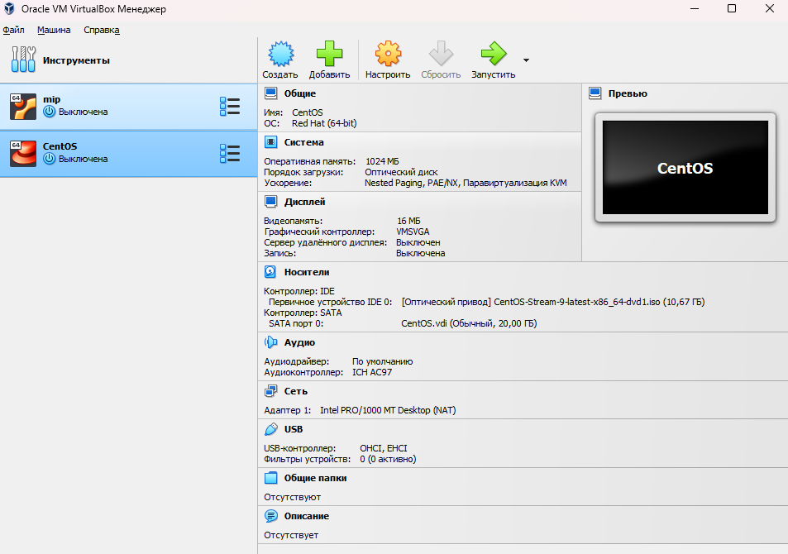

1. Logged in as administrator and updated system elements

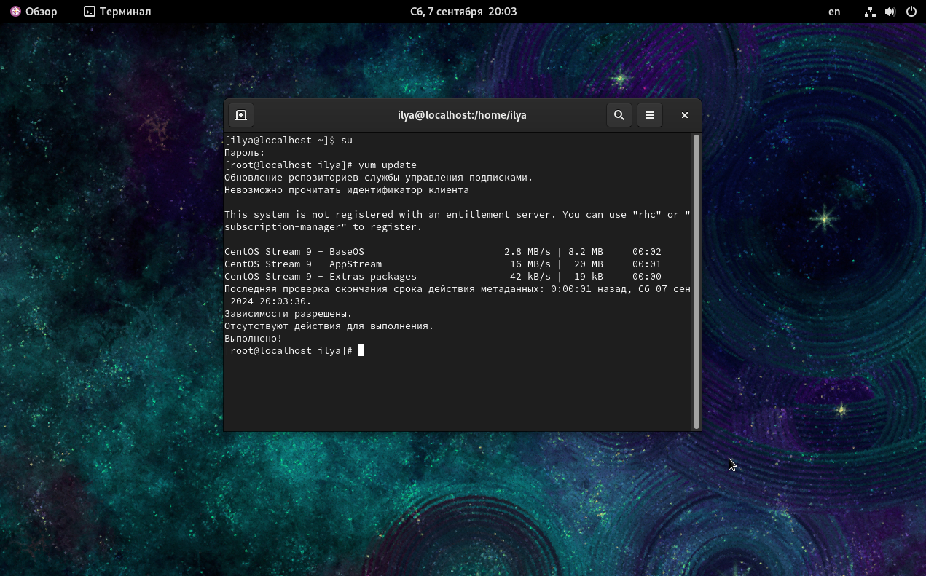

# Conclusion

Completed the task, installed CentOS on a virtual machine, and updated the system.